rAppla

Metric Measurement Plan

Version 1.0

Revision History

|  |  |  |  |
| --- | --- | --- | --- |
| **Date** | **Version** | **Description** | **Author** |
| 11/May/14 | 1.0 | Metrics Measurement Plan for rAppla | rAppla Team |
|  |  |  |  |
|  |  |  |  |
|  |  |  |  |

Table of Contents

1. Introduction 4

1.1Purpose 4

1.2Scope 4

1.3Overview 4

2. Management Goals and Subgoals 4

4. Metrics 5

4.1Metric 1: Too many static attributes 5

4.2Metric 2: Too many Parameters 6

# Introduction

## Purpose

This Measurement Plans aim is to describe the efficiency of code from the rAppla app through Metrics. The Metrics are calculated with a tool called “Metrics 1.3.6” that has been integrated in to the Eclipse IDE in which rAppla is being developed.

## Scope

The Plan should provide the rAppla team members with helpful explanation of the calculated Metrics.

## Overview

This document contains two most focused Metrics for Use cases of rAppla. The Metrics, which have been created by the tool “Metrics 1.3.6”, are shown in the screenshots, with a small explanation, below.

# Management Goals and Subgoals

The measurements should enhance the development of rAppla. Furthermore it should help to zoom into potential trouble spots.

# Metrics

## Metric 1: Too many static attributes

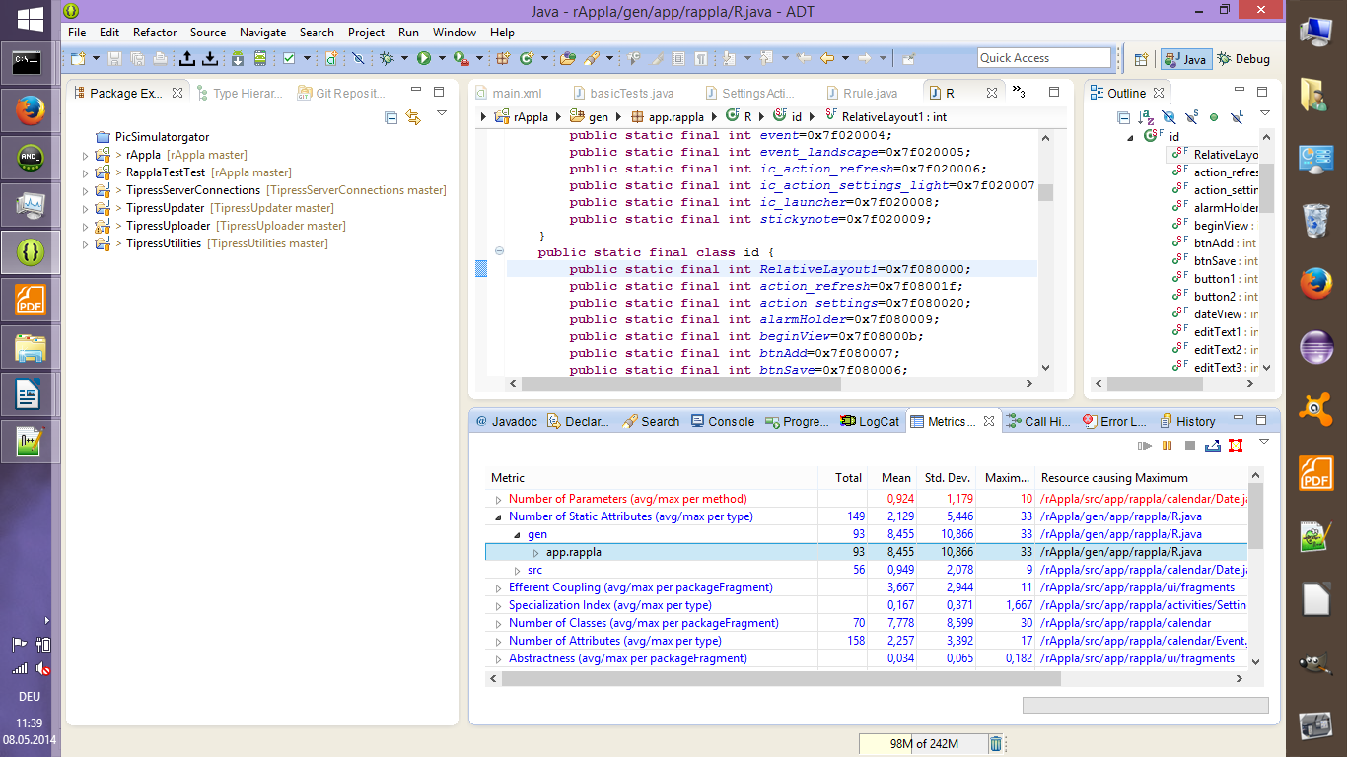

The metric shown in this screenshot complains about high number of static attributes used in code.

The attributes are generated by XML Files in the Eclipse IDE. The metric points out that this can create problems within the rAppla app. Furthermore the code is also shown in the screenshot with the attributes, which the metric is complaining about. This metric is colored blue which means that this issue has a high number of the calculated metric but it is not that high and not necessarily to be of concern.

## Metric 2: Too many Parameters

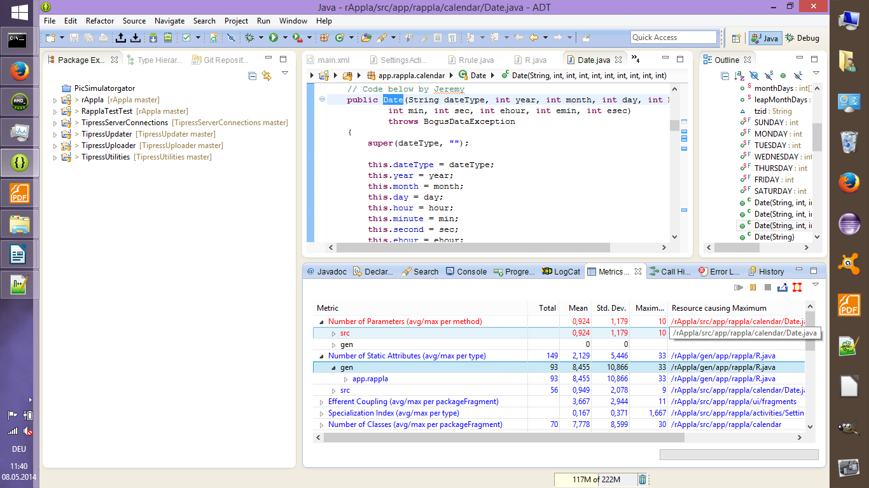

The metric shown in this screenshot complains that the method “public Date” has too many Parameters. It is marked red and should be of concern.